AI Assisted Coding

Lab Test – 04 Date: 12.11.2025 24BTCAICSB01 and 24BTCAICSB02

SET 5
Q1. Generate AI-assisted SQL for a Retail Store Inventory system.
- Tables: Products, Categories, Sales.
- Insert Data in to these three tables
- Write SQL to calculate total sales per category.
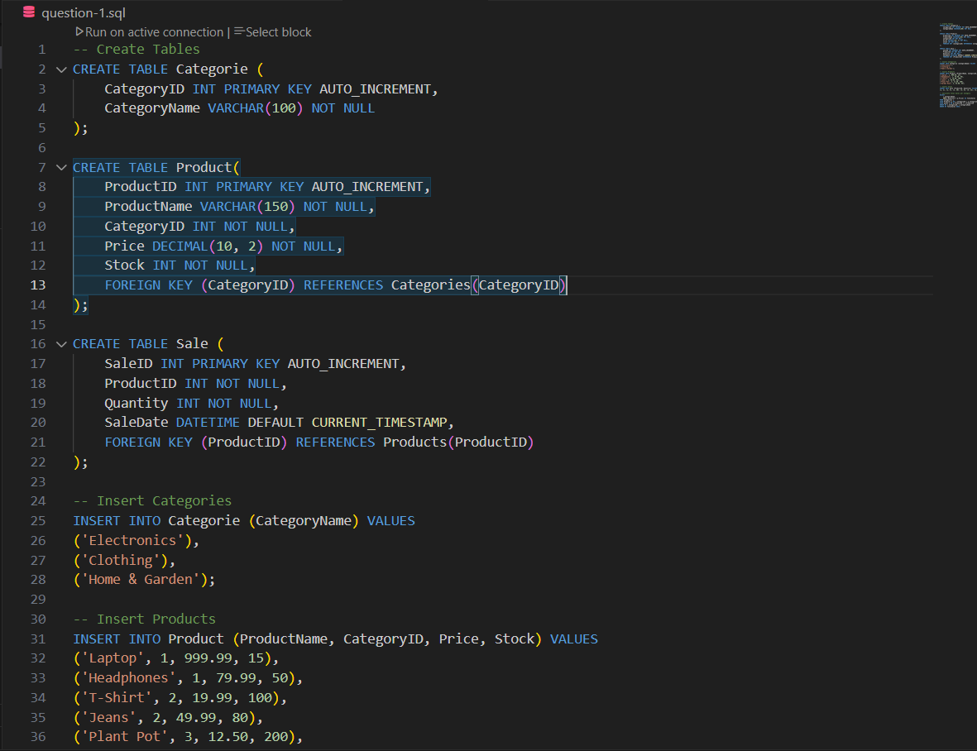
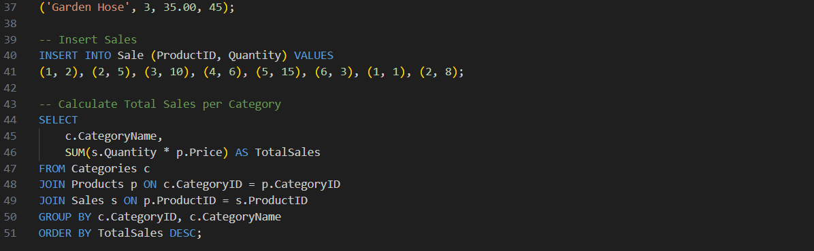
Output:
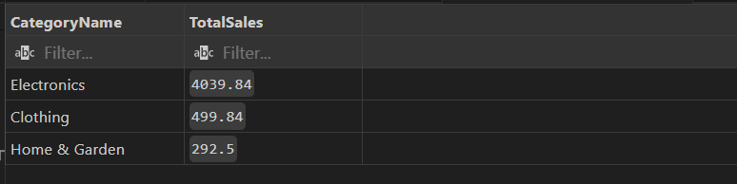
Q2. Use AI to convert a Python list comprehension that filters even numbers into equivalent JavaScript code.
- Compare execution results and discuss differences in syntax and output.

